 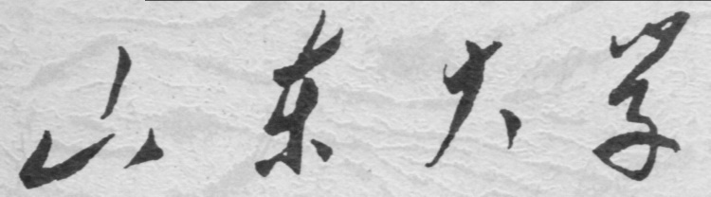

**School of Information Science and Engineering**

**2019－2020 school year**

Digital Image Processing Experiment Report

Course Name： Digital Image Processing

Title of Experiment： The Fourier Tramsform and Its Appliance

Major and Class Class 3, Communication Engineering

Student ID 201600121116

Studeng Name 张子超

Date 2019/3/30

目录

1． Objectives: 2

2． Experiment Content: 2

3． Experiment Principle: 2

4． Experiment Steps: 2

1). Fourier transformation 2

2). Approximate impulse function two-dimensional Fourier transform: 3

3). Spatial filtering and freqency domain filtering. 5

5． Conclusions and Experiences: 7

6． Appendix（Code）: 7

# 1． Objectives:

1.Master the DFT transform in two dimensions and its physical significance.

2.Handle the MATLAB program of DFT transform in two dimensions.

3.Spatial filtering and frequency domain filtering.

# 2． Experiment Content:

Learn to use functions fft2, ifft2, abs, angle, fftshift, imfilter, fspecial, freqz2, and the method for displaying in logarithmic form. Implement the fourier transform forward and reverse, Gaussian low-pass filtering and the laplacian high-pass filtering.

# 3． Experiment Principle:

The image can be processed exactly as how the signal in one dimension is processed. Like the signals, images also have spectrum, representing the variability of one image. Thus, filtering can also be applied in digital processing.

# 4． Experiment Steps:

## 1). Fourier transformation

Load and display image Fig0316(3)(third_from_top).tif and conduct a FFT in two dimension on this figure with an output F. Then shift its DC component to the center of spectrum, get F1. Calculate its real part RR, imaginary part II and phase angle Angle. Calculate its magnitude A1=abs(F1) and A2=sqrt(RR.^2+II.^2) in two ways and display them separately to draw a comparison between them.

As we know, in digital frequency domain, the highest frequency lies in π, and origin point represents the lowest frequency. So directly use the function fft2 will bring the result as below:



The spectrum embodies our theory, the brightest part are the four corners while the darkest part is the center. So this is the right place for fftshift. This function shifts the highest frequency to the central part, making it more easier to tell the spectrum composition.



Now the spectrum do look better.

There is another way to obtain the magnitude of spectrum, that is, extract the real part and the imaginary part of spectrum separately and add them together after squared, at last, square it.



We can see that there’s no difference between them.

## 2). Approximate impulse function two-dimensional Fourier transform:

A=zeros(99,99);A(49:51,49:51)=1. Conduct the fourier transform B of A, then shift the DC component of B to the center, with an output B1. Display the logarithm of A and B’s magnitude separately with function imshow and mesh.

mesh(X,Y,Z) draws a wireframe mesh with color determined by Z, so color is proportional to surface height. If X and Y are vectors, length(X) = n and length(Y) = m, where [m,n] = size(Z). In this case, (X(j), Y(i), Z(i,j)) are the intersections of the wireframe grid lines; X and Y correspond to the columns and rows of Z, respectively.

First of all, get A:



Use the same method, we get the spectrum of A.



With the function mesh, we can get the solid figure of A like above, there’s one thing should be emphasized that mesh function requires three input: X, Y, and Z, X and Y can be structed by meshgrid function, but Z should be a function whose independent variables are X and Y. So I write this code: mesh(X,Y,A). Used A to substitute Z. As well, the spectrum can also be displayed this way:



Though, I didn’t use the logarithm of B in order to correspond to the figure in the instruction book.

## 3). Spatial filtering and freqency domain filtering.

Spatial filtering: obtain a gaussian filter whose size is 9*9 and standard deviation is 2 with the function fspecial.

Frequency domain filtering: use function freq2 to obtain the frequency domain form(256*256) of aforementened gaussian filter and filter the image in frequency domain. At last, conduct an anti fourier transform.

Use function to create a 9*9 gaussian filter w, display it.



Then use function imfilter to filter the figure, the result is as follows:



The image turns out a little fuzzyer than before. Then use the function freqz2to create a frequency domain filter W. And the solid figure is rather easy to draw.

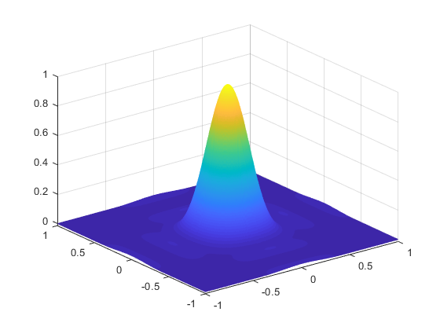

At last, simply multiple the W and spectrum of figure together is OK. The result is as follows



And conduct the ifft2 function, the result is rather surprising.



It’s quite the same with the result we got previously with time domian filtering method.

# 5． Conclusions and Experiences:

During the experiment, I made some mistakes that I should not have made, like I mistoken result of fft as real number, which caused the final result screwed up. The result of frequency domain filtering and the time domain filtering is the same, cause the product in frequency is equivalent to the convlution in time domain. The high frequency part embodies the varying part of the image while the DC component embodies the plain part of image. So when I filtered the image with a low-pass filter, the image got fuzzier, which is because the boundaries are the most dramatic parts.

# 6． Appendix（Code）:

Part 1:

[y,mapy]=imread('G:\desktop documents\2018大三下\数字图像处理资料For students\For students\程序与图像\图像库\Fig0316(3)(third_from_top).tif');

figure;

imshow(y);

F=fft2(y);% non-shifted

logF=log(1+abs(F));

figure;

imshow(logF,[]);

F1=fftshift(F);%shifted figure

logF1=log(1+abs(F1));

figure;

imshow(abs(logF1),[]);

title('using abs() method')

realF=real(F1)

imagF=imag(F1)

awF1=sqrt(realF.^2+imagF.^2)

logawF1=log(1+awF1)

figure

imshow(logawF1,[])

Part 2:

A=zeros(99,99)

A(49:51,49:51)=1

figure

imshow(A,[])

fftA=fft2(A)

fftAs=fftshift(fftA)

logfftAs=log(1+abs(fftAs))

figure

imshow(logfftAs)

[X,Y]=meshgrid(0:98)

Z=0:0.1:1

figure

mesh(X,Y,abs(fftAs))

Part 3:

fdomainy=fft2(y);

fdomainysh=fftshift(fdomainy);

figure

imshow(log(1+abs(fdomainysh)),[]);

w=fspecial('gaussian',[9 9],2);

figure

imshow(w,[])

set(gca,'position',[0 0 1 1])

fi1=imfilter(y,w,'conv','same');

figure;

imshow(fi1,[]);

[W,f1,f2]=freqz2(w,500,500);

figure

mesh(f1,f2,W)

figure

imshow(W,[])

freq_dom_fil=W.*fdomainysh;

figure

imshow(log(1+abs(freq_dom_fil)),[])

iffty=ifft2(freq_dom_fil);

figure

imshow(abs(iffty),[])